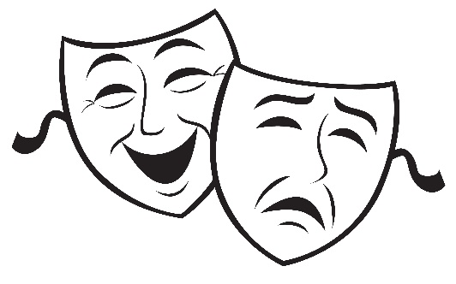
Acting Workshop 104
“10 Lessons in 10 Days of Fun!”
Purpose: The purpose of this class is to provide some basic and complex understandings of theater to children while they are studying a show to perform at the end of the workshop.
Lesson Outline:
Lesson #1—What is a Cold Reading?
Lesson #2—How to prepare for an audition?
Lesson #3—Creating Your Own Character
Lesson #4—What is Your Character Thinking?
Lesson #5—What Does My Character Like to Do?
Lesson #6—Facing the Unexpected
Lesson #7—Famous Characters Around the World (and what we can learn from the actors’ portrayal)
Lesson #8—Articulation & Projection
Lesson #9—Who is Your Character Now?
Lesson #10—Review/What to do with Your Props
Lesson Structure by Hour:
10-10:10—Body Movement Exercises
10:10-10:25—Vocal Warm-Ups
10:25-10:30—5 min. Break
10:35-10:45—Lesson Time
10:45-10:55—Lesson Review/Q&A Time
10:55-11:10—15 Minute Break (students may choose to work on characters/lines, or have a full break on their own)
11:15-11:55—Rehearsal Block Time #1
11:55-12:05—10 Minute Break (students may choose to work on characters/lines, or have a full break on their own)
12:10-12:40—Rehearsal Block Time #2
12:45-12:55—Days Review/Q&A Time

